**NAME VIKRAM KUMAR**

**ID BIT-23F-026**

**SUBJECT ARTIFICAL INTELEGENCE**

**LAB #7**

**SECTION 3A**

**DATE 11-12-2024**

**Lab task 1:**

Write a Python function that draws a square using asterisks (*). The side length of the square should be provided by the user.

**def** draw_square(side_length):

    for i in range(side_length):

        print('*' * side_length)

side_length = int(input("Enter the side length of the square: "))

draw_square(side_length)

**OUTPUT**

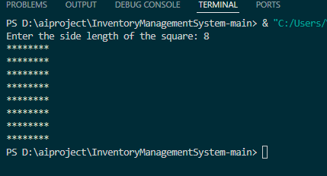

**Lab task 2**

Write a Python function that takes a list of numbers as input and returns the sum of only the even numbers.

**def** sum_of_even_numbers(numbers):

    return sum(num for num in numbers if num % 2 == 0)

numbers = [1, 2, 3, 4, 5, 6, 7, 8, 9, 10]

result = sum_of_even_numbers(numbers)

print("Sum of even numbers:", result)

**OUTPUT**

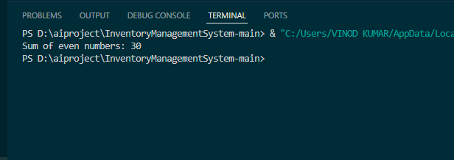

**Lab task 3**

Write a Python function that takes a number as input and counts down to zero, printing each number.

**def** countdown_to_zero(number):

    while number >= 0:

        print(number)

        number -= 1

number = int(input("Enter a number to start countdown: "))

countdown_to_zero(number)

**OUTPUT**

